

PROPOSAL FOR शोध SUPPORT FOR STUDENTS
(Under the SHODH program for research)

- SUMMARY SHEET:

Project proposal submitted under (tick mark the शोध scheme)
□ RISE (Research & Innovation for Science and Engineering)
□ RISoCS (Research & Innovation for Students of Computer Science)
□ RISoM (Research & Innovation for Students of Management)
□ RISoL (Research & Innovation for Students of Law)
□ RISoD (Research & Innovation for Students of Design)
□ RISoL (Research & Innovation for Students of School for Life)
□ RISoHS (Research & Innovation for Students of School Health Sciences)
□ RISoMM (Research & Innovation for Students of School for Modern Media)
□ RISoLS (Research & Innovation for Students of School for Liberal Sciences)

- Title:  Auto Dub using APIs |  |  |  | OFFICE PURPOSE  DATE RECEIVED (in R&D Office):  PROPOSAL No.
 | Duration  (Months)  10 |  | Amount  60,000 | OFFICE PURPOSE  DATE RECEIVED (in R&D Office):  PROPOSAL No.
2. Name and Department of applicants with contact details (email and phone):
*Applicant(s) (Name/Course/Department/SAP ID) & Signature |  | Mentor(s) (Name/Department) & Signature
- Bipul Raj - B. Tech (Computer Science and Engineering) –500084374  E-mail: - 500084374@stu.upes.ac.in  Phone No. - 7051611457 |  | Dr. Achal Agrawal – Computer Science and  Engineering  E-mail: - achal.agrawal@ddn.upes.ac.in  Phone No: - 9898049902
- Jayendra Vardhan Singh - B. Tech (Computer Science and Engineering) –500082718
E-mail: - 500082718@stu.upes.ac.in
Phone No. - 7088345282

* A SHODH team will have minimum 2 students and a maximum of 5 students. SHODH team can have a maximum of 2 mentors (For SoE, there is no limit on number of mentors)
# Do not put any identifying information in Section (B)

(This page intentionally left blank)

(B) DETAILS OF PROPOSAL:
OFFICE PURPOSE
DATE RECEIVED (in R&D Office):

PROPOSAL No.

- Title (Title should be concise & specific)

“Auto Dub using APIs”

- Objectives of the proposal demonstrating contribution to excellence at national level (List pointwise) #

- We are trying to remove language barrier.
- We are trying to create an auto-dubbed software/platform.
- To reduce time dubbing of the video/audio.

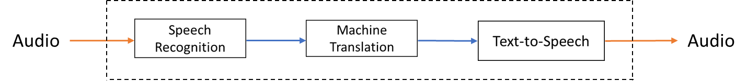

- Expected deliverables of the Proposal (Products/Publications/Patents/ New concept/Spinoff etc.) #

Product- A web interface to simplify the process of dubbing using artificial intelligence.
Publication – benchmarking available APIs for different tasks involved in Automatic Dubbing

- Importance/highlights (3-5 bullet points) #

- Learners will benefit from dubbing technology, as that will assist them in overcoming their language barriers.
- The viewer can focus their entire attention on the graphics as well as the audio when watching dubbed content. The inability to gaze up and down the screen will be eliminated. As their will be no requirement for subtitles.
- No abbreviation is required. There are no dialogues that may be abbreviated because they must be totally rewritten to convey the same message.

- Literature Review and advancement: Demonstrate knowledge of (with references (IEEE format) and contribution to the national state-of-the-art in the relevant area#

Literature Review –
This reference (S. Nakamura et al., "The ATR Multilingual Speech-to-Speech Translation System," in
IEEE Transactions on Audio, Speech, and Language Processing, vol. 14, no. 2, pp. 365-376, March 2006,
doi: 10.1109/TSA.2005.860774.) is basically speech - to - speech translation between English and Asian languages. Whereas in our project we will try to develop speech - to - speech translation b/w English and Indian Native language. We will also do some kind of research in this project that will evaluate which cloud platform (b/w Google Cloud, Microsoft and Amazon AWS) is better that will provide a source to someone who is working on the same project.

References -
- Nakamura S, Markov K, Nakaiwa H, Kikui GI, Kawai H, Jitsuhiro T, Zhang JS, Yamamoto H, Sumita E, Yamamoto S. The ATR multilingual speech-to-speech translation system. IEEE Transactions on Audio, Speech, and Language Processing. 2006 Feb 21;14(2):365-76.
- Weiss, R.J., Chorowski, J., Jaitly, N., Wu, Y. and Chen, Z., 2017. Sequence-to-sequence models can directly translate foreign speech. arXiv preprint arXiv:1703.08581.
- Federico, M., Enyedi, R., Barra-Chicote, R., Giri, R., Isik, U., Krishnaswamy, A. and Sawaf, H., 2020. From speech-to-speech translation to automatic dubbing. arXiv preprint arXiv:2001.06785.

- Alignment to School specific priorities (SoE: State specifically how the proposal supports the Flagship Projects and expected impacts at Cluster and School levels) #

Man-Machine interface, modeling and simulation - social technology which will help learners overcome their language handicap

- Methodology#

Firstly, our project is broken down into 3 parts:
- Speech-to- Text
- Text-to-Text
- Text-to-Speech

We first transcribe the speech of the audio file into the text file using various cloud platforms (Google cloud, Amazon AWS or Microsoft Azure). Then we will translate that text file into the text file of other language through translation APIs. Then, we will screen read the text of other language in an audio or video file. Also, through this we can also compare different cloud services that which one is more accurate and faster. Hence, preferable for speech-to- text, text-to-text, and text-to-speech for different cloud service
providers.

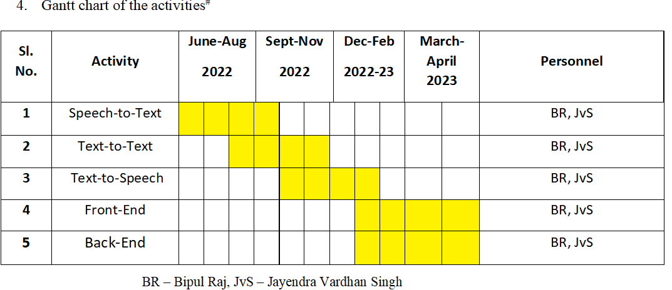
- Budget with justification:
Proposed expenditure | Quantity | Value | Total
Consumables - Cloud Services | 12 months | 30,000 | 30,000
Equipment | - | - | -
Characterization | - | - | -
Any other (please specify) – conference registration and travel |  | 30,000 | 30,000
Total Budget |  |  | 60,000

Justification item wise:

Note: 1) Please attach one-page CVs of Mentors.
2) If required, annexures may be used for items 2-8.

